JVH
Student Handbook

2021-2022

JVH School

Welcome to this new year at JVH!

At JVH, we celebrate the development and evolution of learning opportunities in partnerships with students, families, staff, and community. We are privileged to be one of British Columbia’s growing number of K-12 schools, and our learning community spans all ages, including early learners and adult learners. We intend to continue to develop learning experiences that are relevant, engaging, and rigorous and that help develop excitement and empowerment for life-long learning. We invite students to become active contributors to our community by joining sports teams, clubs, extra-curricular events and more.

This handbook is designed to facilitate a positive learning environment for all. While we place a high emphasis on clarity through this document, we also know that strong relationships and ongoing conversations are instrumental in supporting optimal learning. Please contact our office with any questions, suggestions, or concerns.

Victoria McAllister,
Principal J. V. Humphries K-12 School and Jewett Elementary School
Email: victoria.mcallister@sd8.bc.ca
Office: 250-353-2227
Website: https://jvh.sd8.bc.ca/
District: www.sd8.bc.ca

School District No. 8 Kootenay Lake: Expectations for Learning

Our SD8 Board of Education recognizes and promotes the idea that learning and success are not easily defined and are multi-dimensional. With this in mind, they have published the following framework to guide our support of student learning.

Academic Success
- All students will possess the knowledge, skills and attitudes required for academic success, and be effectively prepared for life, work and further learning.
- All learners will be challenged according to their individual potential.
- All students will develop a confidence to advocate for their personal learning needs.

Creativity and Imagination
- Each student will identify and actively develop individual gifts, talents and interests in order to be actively and meaningfully engaged in learning.

Citizenship
- Each student will be a responsible citizen by being an informed and involved member in his or her local, national and global community—within the context of our diverse rural environment.

Resiliency
- Each student will learn responsible and effective means of self-advocacy.
- Each student will be aware of challenges to overcome and opportunities for growth.
- Each student will understand their own social, emotional, learning and mental health challenges, and articulate a means to seek support to mitigate these challenges.
- Each student will have the opportunity to identify with role models, and define who they want to become.

Please see SD8 Strategic Plan –for the full document.

Student Handbook Table of Contents

Topic | Page
Teacher Contact List | 5
JVH and SD8 Code of Conduct | 6
Consequences & Interventions Framework | 7-8
Consequences & Interventions Details | 8 -9
JVH Actions, Rights, and Responsibilities for All | 9
2021-2022 District Calendar | 10
2021-2022 School Calendar | 11
JVH Daily Schedule | 12
Details for Students and Parents
Attendance  Bikes & Skateboards  Bus Guidelines | 13  14  14
Cell Phone Use  Changing Courses  Cheating & Plagiarism | 14  15  15
Communication Process to Resolve Complaints  Counselling Services  Dress | 15  16  16
Extra-Curricular Participation  Fees  Financial Hardship | 16-17  17  17
Final Exams  Grade Appeals  Grading | 17-18  18  18-19
Graduation Program  Guests at School & Criminal Record Checks  Harassment or Bullying of Students | 20  20  20
Health Care and Student Accident Procedures  Health Hub  Interim Reports & Incomplete Forms | 20-21  21  21
Lockers & Locks  Lost & Found  Secondary Timetable | 21  21  22
Smoking & Vaping  Student Parking & Transportation  Students Suspended from School | 23  23  23
Substance Use & Possession  Technology Use  Textbooks & Library Books | 23  24  24
Weapons & Knives  Withdrawal from a Course or from School | 25  25
Appendix A-Process for Dealing with Reports of Bullying | 26-28

Teacher Contact List

 | Name | email
Principal | Ms. Victoria McAllister | victoria.mcallister@sd8.bc.ca
Secretary | Ms. Marlene Wiens | Clerical.jvh@sd8.bc.ca
Teachers
Primary - 1 | Ms. Sarah Pollick | sarah.pollick@sd8.bc.ca
Primary - 2 | Ms. Molly Leathwood | molly.leathwood@sd8.bc.ca
Primary - 3 | Ms. Kate Okros | kate.okros@sd8.bc.ca
Intermediate - 1 | Ms. Keely Grunerud | Keely.grunerud@sd8.bc.ca
Intermediate - 2 | Ms. Nancy Patience | nancyjo.patience@sd8.bc.ca
Elementry + secondary | Ms. Brenna Leitch | Brenna.leitch@sd8.bc.ca
Elementary + secondary | Ms. Katie Cartier | katherine.cartier@sd8.bc.ca
Secondary teachers, Various Subjects
 | Mr. Cam Zuk | cam.zuk@sd8.bc.ca
 | Mr. Steve Anderson | steve.anderson@sd8.bc.ca
 | Mr. Ian Einer | ian.einer@sd8.bc.ca
 | Ms. Jill Holland | jill.holland@sd8.bc.ca
 | Ms. Grace Broadfoot | Grace.broadfoot@sd8.bc.ca
 | Ms. Meleana Terlingen | meleana.terlingen@sd8.bc.ca
 | Mr. Alastair McKay | Alastair.mckay@sd8.bc.ca
Inclusion Support Teacher | Ms. Kare Cathro | kare.cathro@sd8.bc.ca
Inclusion Support co-teacher | Ms. Yvonne Bousfield | yvonne.bousfield@sd8.bc.ca
Academic Counselor | Ms. Meleana Terlingen | meleana.terlingen@sd8.bc.ca
Teacher-Librarian & Aboriginal Education | Mr. Alastair McKay | Alastair.mckay@sd8.bc.ca
HomeLinks Teacher | Ms. Sarah Keenan | sarah.keenan@sd8.bc.ca

Code of Conduct

For all Students, Staff, Parents and Volunteers:

Expected Behavior

1. Respect
Students are expected to show respect for people, property, and the school's code of conduct. They are expected to act in a responsible manner and be respectful of the rights of others at school and school activities wherever held.

2. Responsibility
Students are expected to gradually assume more responsibility for themselves, as individuals and members of society. They are expected to become more responsible for undertaking, organizing and completing their schoolwork and for contributing to and promoting a safe, caring and positive school environment.

3. Commitment
Students are expected to strive for excellence in all their school endeavors and comply with school expectations and rules for student work, attendance, behaviour, and deportment.

4. Attitude
Students are expected to participate willingly and diligently in their assigned work and to undertake school activities with a spirit of cooperation and fair play

Compliance with the Code of Conduct
It is expected that students will abide by the District and School Code of Conduct going to and from school, on school buses, at school, and at school activities wherever held.

Retaliation Concerns
Schools and the district will take necessary measures to prevent any retaliation against a student who has made a complaint of a breach of code of conduct.

Consequences & Interventions Framework

At JVH… we believe that all members of our school community have the right to learn, be safe and respected, and to be treated with kindness. Our discipline model is based on the rights and responsibilities of our students.

Our Motto:
Be Kind – Be Safe – Be Respectful – Be a Learner

Application of the School Code of Conduct:
All of the following expectations apply to behaviour in all school learning spaces, during school-organized or sponsored activities, as well beyond the school and online if it impacts the safe, caring or orderly environment of our school and/or student learning.

Rising expectations:
As students move from grade to grade it is expected that they have increasing personal responsibility and self-discipline.

Consequences & Interventions:
      - School staff will consider the severity and frequency of unacceptable conduct of the student in determining disciplinary action.
      - Consequences & interventions will be applied in a fair and consistent manner, respecting individual rights, responsibilities, age, maturity, and any special considerations that apply to the student regarding special needs, if they are unable to comply due to having intellectual, physical, sensory, emotional, or behavioural differences.
      - Disciplinary action will focus on corrective rather than punitive measures and on the individual taking ownership of mistakes.
      - Our school will treat seriously behaviour or communication that discriminates based on race, colour, ancestry, place of origin, religion, marital status, family status, physical or mental differences, sex or sexual orientation (prohibited grounds from the BC Human Rights Code).
      - Students, as often as possible, are encouraged to participate in the development of meaningful consequences for violations of the established code of conduct.

Potential consequences & interventions include:
- Conversation with student
- Clarity of Code of Conduct and expectations for behavior that is kind, safe, respectful, and supports learning
- Supervised time to fix mistake &/or give back to the school/community
- Involvement of family (parent/guardian)
- Student-involved plan to change behavior
- School or community counseling or Conflict resolution meetings
- Student-parent/guardian-staff contract to change behavior
- Alternate supervised learning space or partial day school program
- Suspension (as per SD8 policy 300 - http://www.sd8.bc.ca/policy/300%20-%20Student%20Conduct%20Discipline%20-%20Apr%201%202014.pdf )

Notification:
School staff may, depending on the severity and frequency of unacceptable conduct:
- Have students inform parents/guardians directly about instances of unacceptable conduct
- Contact and inform parents/guardians directly about a student’s unacceptable conduct
- Inform the parents/guardians of students who have been the victims of unacceptable conduct
- Inform school district officials as required by district policies
- Inform the police or other agencies as required by law
- Inform staff and the school community as deemed appropriate by the school and/or district administration

Consequences and Interventions Details

- Consequences/Interventions for behaviours that are disruptive to a positive learning environment, including, but not limited to:
- Uncooperative behaviour/ unkind words
- Unexcused absence (skipping) or Repeated lateness
- Teasing
- Inappropriate dress
- Profanity
- Loudness/interruptions
- Running in hallways, pushing, throwing objects
- Littering
- Unapproved use of technology

Initial Behaviour | Developing Trend of Behaviour | Behaviour that is not being corrected
- Conversation with student and potentially with parent/guardian  - Clarity of Code of Conduct and expectations for behavior that is kind, safe, respectful, and supports learning  Staff member(s) involved will use personal discretion for when to get support from administration. | - Supervised time in order to fix mistake &/or give back to the school/community  - Involvement of family (parent/guardian)  - Student-involved plan to change behavior  - School or community counseling  - Conflict resolution meetings  Staff member(s) involved will use personal discretion for when to get support from administration. | - Student-parent/guardian-staff contract to change behavior  - Alternate supervised learning space  - Partial day school program  - Suspension  Administration will be involved in all consequences/interventions at this level.

- The following will involve the administration immediately. This list is not exhaustive.
- Outright defiance toward any staff member
- Cheating/plagiarizing
- Substance use/possession/trafficking
- Harassment/Bullying
- Racist, Sexist or Homophobic comments
- Theft or Property damage/vandalism
- Assault/threats of abuse
- Possession of a dangerous weapon or replica

JVH Actions, Rights, and Responsibilities for All

Actions  Everyone at JVH will… | Rights  I have the right… | Responsibilities  I have the responsibility…
Be Kind | - to a safe, supportive and positive school community | - to treat others with respect and dignity regardless of gender, race, culture, or beliefs.  - to work through conflicts in a compassionate and non-violent way.  - to get support when I need help with a conflict.
Be Safe | - to a safe, clean and healthy physical environment | - to ensure that the school is free from litter, theft, and vandalism.  - to neither bring nor use tobacco, drugs, or alcohol.  - to keep the school free from dangerous materials (real or replicas).  - to keep the school free from threats, abuse and violence.
Be Respectful | - to express myself appropriately and be listened to | - to care for myself and others.  - to take into consideration the opinions of others.  - to speak respectfully at appropriate times and to listen to others politely.
Be a Learner | - to an education and to learn | - to meet school and classroom expectations.  - to be engaged in my learning and to give my best effort.  - to cooperate with others.

Calendars
SD8 District Calendar:
- Sept. 30 is a statutory holiday, Truth and Reconciliation Day.
- JVH and Jewett Early Dismissal Days are different from this calendar.
- You can find this calendar on the SD8 Website: https://www.sd8.bc.ca/calendar/downloads

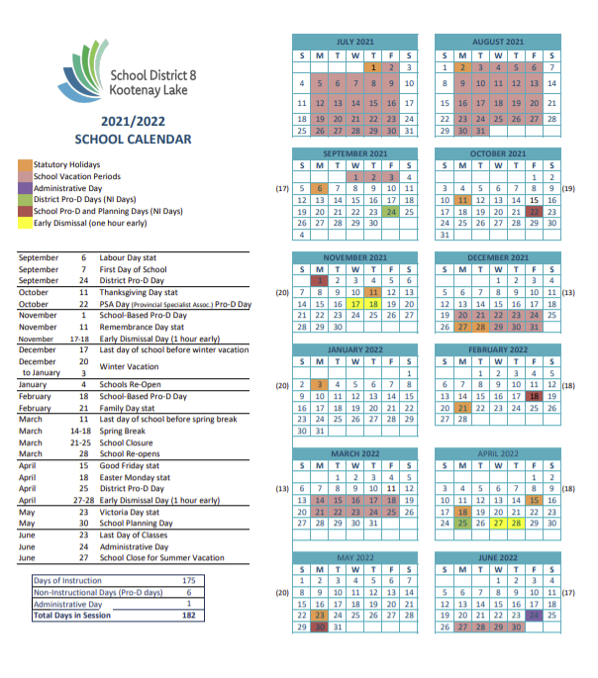

JVH K-12 Calendar
Additional details and dates are posted weekly on our Website: https://jvh.sd8.bc.ca/
* Please note- JVH and JES have different Early Dismissal Days from the rest of our district

August 25 Office re-opens, 8AM to 4 PM Monday - Friday
September 07 First Day of School for students – ½ day
September 24 Pro. D. Day (District) – no school for students
September 30 Truth and Reconciliation Day Statutory Holiday
October 07 Individual Photo Day
October 11 Thanksgiving Day - school closed
October 19-21 * Early Dismissal Days (one hour early) – conferencing available
October 21 Secondary informal communication with families completed (verbal/ written)
October 22 Pro. D. Day (PSA) – no school for students
October 25 Elementary informal reporting with all families completed
November 01 School-Based Pro. D. Day (no school for students)
November 11 Remembrance Day Statutory Holiday – school closed
November 12 Secondary Quarter 1 ends
November 19 Secondary Q.1 Report Cards Issued
December 03 Elementary Term 1 ends
December 14 Elementary MyEd reports emailed home
December 16 Elementary Winter Celebration
December 17 Last Day of Classes Before Winter Holiday
January 04 School Re-opens
January 25 Secondary Quarter 2, Semester 1 Ends
February 02 Secondary Report Cards issued
February 18 School-Based Pro. D. Day (no school for students)
February 21 Family Day – school closed
March 03 Secondary Interim Report (as needed, verbal or written)
March 04 Elementary Term 2 ends
March 11 Elementary Reporting to parents
March 11 Last Day of Classes Before Spring Break and school closure week
March 28 School Reopens from Spring Break
April 11 Secondary Quarter 3 Ends
April 15-18 Easter Weekend, Friday and Monday (school closed)
April 19 Secondary Report Cards Issued
April 25 District Pro. D. Day (no school for students)
April 26-29 Gr. 10 &12 Literacy and gr. 10 Numeracy Provincial Assessments
April 27 Early Dismissal Day (one hour early) – conferencing available
May 23 Victoria Day – school closed
May 30 School Planning Day (no school for students)
June 14-17 Secondary Exams
June 18 Grade 12 Graduation Events and Ceremony
June 20 Semester 2, Q. 4 Ends
June 20-23 Secondary Work and project completion
June 23 Elementary and Secondary Report Cards Issued
June 23 Awards Ceremony

J.V. Humphries School Daily Schedule – 2021-2022

Elementary (gr. K-7) Schedule (301 min)
8:40-10:30 Morning session (110 min)
10:30 – 10:45 Recess
10:45-12:05 Mid-morning Session (80)
12:05-12:55 Lunch
12:55-2:46 Afternoon Session (111)
3:08 Bus Departure

Secondary (gr. 8-12) Schedule (327min)
8:45 – 9:51 1st Learning Block
9:55 – 11:01 2nd Learning Block
11:05 – 12:10 3rd Learning Block
12:10 – 12:48 Lunch
12:48 – 1:53 4th Learning Block
1:57 – 3:02 5th Learning Block
3:08 Bus Departure

Bells will ring at:
8:40 Elementary Start of Day
10:45 Elementary End of Recess
12:35 Primary time to come inside from play before lunch
12:48 Secondary Start of Afternoon
3:02 Secondary End of Day

Details for Students and Parents

You can access School District 8 Board Policies, here: https://www.sd8.bc.ca/board/policies

Attendance

If a student is absent, they lose the educational benefits of a class. Often, it is impossible to make up the missed experience - at least in its entirety - and to gain from this learning experience to the same degree that students would through group involvement in regular classes.

For safety reasons, it is important for us to know where students are at all times.

- Expectations & Protocols

- It is expected that students will attend full classes every school day.
- All teachers will take attendance and keep a record of absences and lateness in MyEducationBC. Administration regularly analyzes absences and lates of individual students and will address any trends that emerge.
- It is the responsibility of the parent/guardian of an absent student to contact the school for all absences. This is best done by emailing our secretary Ms. Wiens at clerical.jvh@sd8.bc.ca and including the specific teachers of all missed classes or using the Report Absence function on our website: https://jvh.sd8.bc.ca/absence-late
(Teachers’ email addresses are listed in this handbook and on our website.)
  - For K-7 students, if the school does not receive a message regarding an absence, parents/guardians will be contacted that day by our secretary.
  - For grades 8-12 students, teachers may contact a parent/guardian in the event of a questionable absence. Administration will also become involved if there is concern about an unexcused absence and if a trend in absences is developing for a student.
  - In an effort to stress the importance of daily attendance and parent communication with our school, students in grades 8-12 will have to stay after school to make up time for unexcused absences, and be required to be in a study session rather than have the option for sports or other activities during the TAG block.
- If a family is planning a multi-day absence, parents/guardians and students should understand that teachers likely cannot pre-teach the lessons, nor provide make-up assignments to cover all the learning that will be missed.
- Teachers will, within reason, attempt to provide make-up work for excused absences.
- Students who arrive late to school are expected to report to the main office to sign in. Students who are excused to leave early must report to the office to sign out.
- Students who are absent from any of their scheduled classes on the day of a co-curricular or extra-curricular activity (eg: a field trip, a sports practice or game, etc.) in which they are scheduled to take part may not be allowed to participate in that activity. Exceptions may be made for excused absences communicated through the office.
- Teachers will indicate due dates for work. The responsibility for timely completion of all make-up requirements rests with the student, with family support.
- If a school-related activity requires that students miss class time, students must inform the teachers of the classes they will miss in advance.
Bikes & Skateboards

- Bicycles must be parked in the racks provided. It is recommended that students bring and use bicycle locks. Students must wear helmets to and from school and during any bicycling activities organized by the school. We welcome student-organized bicycle days and will support the safe use of shared spaces. These days must be planned with staff in advance. Students are not to interfere with others’ bikes, helmets, or other equipment.
- Skateboarding on school property during school hours is permitted, under supervision, during pre-arranged times in identified locations. Helmets must be worn while skateboarding. Skateboards are not to be taken to classrooms. If a student does not want to store his/her skateboard in a locker, it can be stored each day in the office. Skateboards on the bus must be enclosed in a bag.
- Skateboard wheels damage the flooring surfacing, even beyond what can be seen. We will address seriously any concerns that come up regarding any wheeled devices within the school building.

Bus Guidelines

To ensure safety, students who travel on school buses are expected to obey all rules, which will be explained by the bus driver. Infractions of bus rules may result in the suspension of bus privileges, and/or other disciplinary actions, which involve district level responses from our Transportation Coordinator.

Where students are found responsible for damage to busses, they and/or their parents/guardians or guardians, will be liable for the cost of repairs. These guidelines are for appropriate student conduct while under the jurisdiction of the school. This includes traveling to and from school, while at school and while at any school sponsored function whenever and wherever held. Buses are equipped with video surveillance.
The Bus Code of Conduct can be found on the SD8 Website: https://www.sd8.bc.ca/node/36712

Cell Phone Use

Grades K-7:
Cell Phone use is not permitted in elementary grades. However, if a student needs a cell phone at school, they will do so in agreement with their classroom teacher and their parents.
Grades 8-12:
Cell Phone Use is permitted during non-class time. Each teacher has their own rules about cell phones in their classes.
Any student not following the teacher’s rules about cell phone use will have their cell phone brought to the office. Students may come to the office at the end of the day to pick up their phone. If it happens repeatedly, parents will need to come to get the phone.

Changing Courses

The school timetable is prepared on the basis of learning experiences that are required by the BC Ministry of Education, in combination with what students and families select. Administration has full authority in the placement of students and will make final decisions in this regard. Where it is approved by teachers and the counselor, and where numbers permit, students may change courses with the counselor’s approval during a period of time that will be communicated to students. After this time period, the counselor and/or administration will make decisions regarding possible changes in any course or program.

Cheating & Plagiarism

Cheating and plagiarism, in any form, will not be accepted. Any student involved with cheating and plagiarism will be referred to the administration for further action.

Communication Process for Parents to Resolve Concerns

Please see https://www.sd8.bc.ca/sites/default/files/SD8_Comm-Parents-Brochure.pdf for details

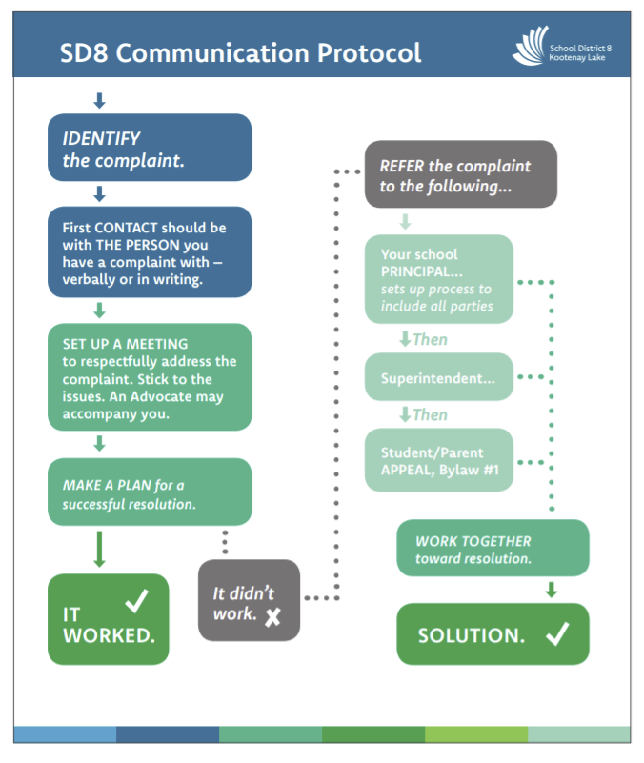

Counselling Services

- Academic counselling is available for elementary and secondary students. The academic counsellor assists students in planning their programs, working on portfolios, discussing post-secondary education, planning for scholarships, and developing good work/study habits.
- Some social-emotional supports are available for elementary and secondary students to help them with personal concerns.
- Our counsellor and Youth and Family Workers can also help students make contact with community agencies that can provide support.
- Our counsellor is available during the school day and by appointment.

Dress

We understand that student dress is highly personal and an important form of self-expression and a controversial issue in schools. At the same time, we are a K-12 school and a public space with expectations for how we present ourselves.

Clothing needs to be safe for each learning space and free from any reference to substances that are illegal for youth, gangs, hate, obscenity, profanity, racism, discrimination, and sexual references. Students wearing clothes that are deemed by staff to be inappropriate for the environment or too revealing may be referred to administration for a respectful conversation and plan of action.

For the safety of all students, students are required to wear shoes at all times both inside the school and on the playing fields.

Extra-Curricular Participation

JVH values the importance of extra-curricular activities as part of the learning that happens at school. Participation in extracurricular activities is encouraged for all. Nevertheless, participation is a privilege earned through demonstrating behaviours that meet school policies and our Code of Conduct.

Students involved in extra-curricular activities are ambassadors for the school and have high expectations placed upon their behaviour. District policy 440 https://www.sd8.bc.ca/sites/default/files/AP%20441.1%20Student%20Eligibility%20for%20Extra-Curricular%20Activities.pdf outlines the expectations for all involved. Any student involved with alcohol or drugs while participating in a school sponsored activity may be immediately removed from all extra-curricular activities during that season of play and may be prohibited from further extra-curricular activities throughout the year.

A student’s behaviours and/or work habits may result in not being able to participate in particular extra-curricular activities. Any concerns from staff regarding a student’s participation will be brought to administration.

Each coach/sponsor will establish team/club rules in collaboration with administration. Team/club rules will be distributed and discussed with parents/guardians and participants prior to the beginning of the activity. Students are expected to comply with team/club rules and might forfeit their eligibility through noncompliance.

Board Policy prohibits the use of student-driven vehicles for school-based activities. Any parent/guardian/community member who wishes to drive students on a school-based trip must have a current driver’s abstract, vehicle registration and insurance policy on file at the school.

All students are welcome to help organize, lead, and participate in intramurals, clubs, evening activities and are encouraged to speak with administration and/or a sponsor teacher for support.

Fees

Class | Cost per child | To Cover
Elementary (K to 7) | $40 | All School supplies, agendas etc.
Secondary (Gr. 8-12) | $20 | Locks / project materials

Financial Hardship

Provisions for Financial Hardship will be made through the office. Please contact our principal or secretary to request supports for fees for supplies or field trips as needed.

Final Exams (School-Based)

A schedule of final exams will be made available to all students prior to the end of a semester. Students must write their exams on the scheduled dates. If a student is excusably absent on the date of the scheduled exam, he/she must notify the school prior to the scheduled writing time of the exam. The school, in conjunction with the student, will reschedule the exam. (Note: The school cannot reschedule any provincial exams.)

Students must comply with the following rules governing final examinations. Any infractions will be referred to administration.

- Know the date and time of the exam and the number of the room in which you are to write.
- Be in the exam room at least five minutes before the examination is scheduled to begin.
- Students will not be permitted if more than 30 minutes late
- Students are not permitted to go to the washroom for the first 30 minutes after the exam begins
- Students must remain in the exam room for a minimum of an hour
- Before entering the examination room, supply yourself with the necessary writing equipment and mathematical instruments where applicable.
- Do not take books of any kind into the room with you, unless directed by the teacher.
- All personal electronic devices not approved for use during the exam are to be turned off and given to the exam supervisor.
- Students shall not make use of papers or notes other than those supplied by the supervisor.
- Students shall not give or receive assistance of any type.
- Students shall not speak or communicate in any manner with other students while writing exams, unless directed by the teacher.
- Students shall not leave their seats without permission.
- Students must interpret questions on the examination paper. The teacher supervising the exam has no authority to help with anything that appears on the examination paper.

Grade Appeals

Students are entitled to appeal their marks. Appeals begin with the classroom teacher. Students may appeal their final course mark to the principal if they feel that there has been an error or injustice.

Grading

The Ministry of Education is in the process of creating and sharing with us a new Reporting Order. For details of the Pilot K-9 reporting policy, see: https://curriculum.gov.bc.ca/sites/curriculum.gov.bc.ca/files/pdf/reporting/student-reporting-policy-pilot-handbook.pdf
SD8 is involved in the pilot and details can be found here: 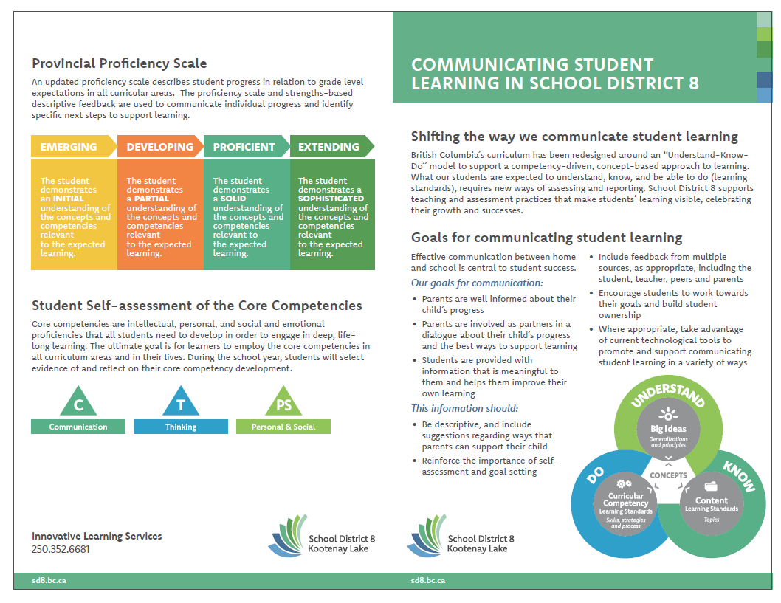
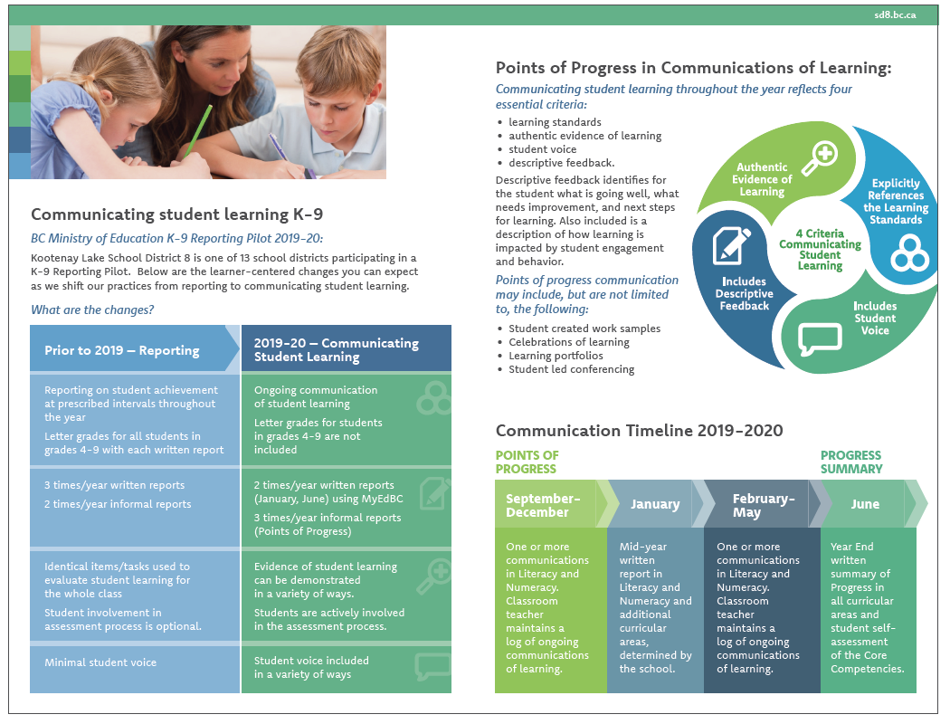
For now, at JVH grades 8-12 are as follows, and we will notify you when grades 8 & 9 change to the new model.

- Grades 8-12 – Progress in relation to expected learning outcomes is represented as:

- A = 86%-100% Excellent or outstanding performance in relation to learning
outcomes
  - B = 73% - 85% Very good performance in relation to learning outcomes
  - C+ = 67% - 72% Good performance in relation to learning outcomes
  - C = 60%-66% Satisfactory performance in relation to learning outcomes
  - C- = 50% - 59% Minimally acceptable performance in relation to learning
outcomes
  - F = 0% - 49% No demonstration of minimally acceptable performance in
relation to learning outcomes for the course
  - I = Incomplete: No demonstration of minimally acceptable performance in
relation to learning outcomes in this reporting period

Graduation Program

For detailed information on the grades 10-12 Graduation Program, see https://www2.gov.bc.ca/assets/gov/education/kindergarten-to-grade-12/support/graduation/graduation-policy-guide.pdf and talk with our academic counsellor.

These are the minimum requirements for a Secondary School Graduation Diploma. Many courses have prerequisites that should be completed before the next course can be attempted. Students planning for post-secondary admission are advised to see our academic counsellor to determine entrance requirements for specific programs and institutions.

It is important to note that the province of B.C. is involved in a process of transforming our Graduation Requirements to be more current. Please see https://curriculum.gov.bc.ca/ for details.

Guests at School

Parents/guardians are welcome to visit the school (as Covid Protocols allow). Please arrange ahead of time with individual teachers for the best time to visit a class. All guests are expected to register at the office prior to proceeding to other areas of the school. Unregistered guests may be asked to leave the building. Student guests are permitted on an occasional basis, as cleared with the principal, as long as such visits do not disrupt normal school routines. As with other guests, student guests must sign in at the office. Student guests are permitted to attend a class only with permission from the office, and with each teacher's permission.
Any parents/guardians/former students/community members who wish to volunteer to help with longer out of school fieldtrips will need a Criminal Record Check. These can take some time to complete, so please contact our office as soon convenient to start the process.

Harassment or Bullying of Students

The staff of J.V. Humphries believe that students, whether at school or participating in a school-sponsored activity, should be made to feel welcome and positive about the school and its activities. Harassment and bullying issues will be responded to and will be addressed through our ‘Process for Dealing with Reports of Bullying’. See Appendix A.

Health Care and Student Accident Procedures

Except in cases of emergency, students who become ill or who have suffered a minor injury at school will be cared for at the school. Parents/guardians will be contacted when the illness necessitates the student missing class or when medical attention is required. Where there is an immediate concern for a student's health, the school will summon an ambulance or take the student immediately to the hospital. In emergency cases, parents/guardians will be contacted while the student is transported to the hospital. Each year, students will be asked to provide the office with updated health information, including name(s) of doctor(s), dentist(s), and any health concerns (e.g. allergies). Medications are not administered to students by school staff, unless a health protocol has been formalized. Members of school athletic teams are advised to have a routine medical examination at the start of each season. In some cases, coaches or administrators may require students to have a medical examination prior to participation.

‘Kids Plus Accident Insurance’ is available each year for purchase. See www.kidsplus.ca
Health Hub

Our Health Hub is open weekly for secondary students to book appointments with local physicians or Options for Sexual Health. We are incredibly grateful to our 3 local doctors and Options volunteers for coming to our school weekly to support our youth with their physical and mental health.

Interim Reports and Incomplete Forms

Interim reports and/or Incomplete work will be communicated between official report card periods to parents/guardians. This may take various forms, including paper-based reports, emails, phone calls, and/or in-person conversations.
*Any student who is at risk of failing will receive an “In progress or Incomplete” report prior to receiving a failing grade on the report card.

Lockers and Locks

We recommend that lockers be kept locked. The purpose is:
1. To prevent theft from lockers.
2. To prevent abuse of and vandalism of the lockers.

Each student will be held responsible for the locker assigned, and any damage or defacement of the locker will be rectified by the student concerned.

Lockers will be assigned at the beginning of the school year. Students are expected to use only the lockers assigned to them. Locks may be purchased at the office for $5. Items that are very valuable, including money, should not be kept in lockers. The office will assist you in storing items of this nature, including skateboards.

All lockers are the property of the school. Where a student is suspected of keeping in the locker items, articles, or materials contrary to those permitted by the school or by the Criminal Code of Canada, the administration retains the right to search lockers.

All lockers must be emptied on the last day of the student's final class. Unclaimed items will be donated to charity or discarded.

Lost and Found

The school’s main "Lost & Found" is located at the front entrance to the school. The primary “Lost & Found” is located at the primary end. Students are cautioned not to bring large sums of money or valuables to school. These items can be stored, if necessary, at the office. Students are responsible for the care and safety of all their personal belongings. The school cannot accept responsibility for lost or stolen articles. Any and all items remaining in the "Lost and Found" at the end of each school year will be donated to a local charity or discarded.
JVH – 2021-22 Secondary Timetable – (327 min. per day)
 | Monday | Tuesday | Wednesday | Thursday | Friday
8:45-9:51  (66) | Block 1  - Eng. 8- CZ  - Science 9– GB  - Eng. 10 - JH  - Bio 11 (1/2)- IE | Block 4  - Sc 8 – MT  - CE 9, S1- CZ  MS 9, S2- AM  - MS 10, S1- AM  CLE 10, S2- CZ  - Math 11 – IE  - Math 12 -NJP | EXP-A - Sem. 1:  - Foods 8-12- MT  - Spanish 8-12 – NJP  - Art Journal 8-12 JH  - Fitness 8-12- CZ  Exp A – Sem 2:  - Restoration & design 8-12 - JH  - Foods 8-12- MT  - Shop 8-12 SA  - Dance 8-12 – NJP  OTT Sem. 2  - Leadership 8-12 CZ | Block 3  - PE 8/10- CZ  - Eng. 9 – JH  - Chem 11/12- IE  - Psychology 11/12 2nd Sem - KC | Block 4  - Sc 8 – MT  - CE 9, S1- CZ  MS 9, S2- AM  - MS 10, S1- AM  CLE 10, S2- CZ  - Math 11 – IE  - Math 12 -NJP
9:55-11:01  (66) | Block 2  - SS 8 - BL  - SS 9 - JH  - SS 10 – GB  - Chem 11/12- IE  - Activate, PT, WEx. – MT  - Psychology 11/12 2nd Sem - KC | Block 6  - Math 8 – BL  - PE 9 - CZ  - Math 10 – IE  - Socials 11- GB  - Eng. 12- JH | EXP-A - Sem. 1:  - Foods 8-12- MT  - Spanish 8-12 – NJP  - Art Journal 8-12 JH  - Fitness 8-12- CZ  Exp A – Sem 2:  - Restoration & design 8-12 JH  - Foods 8-12- MT  - Shop 8-12 SA  - Dance 8-12 – NJP  OTT Sem. 2  - Leadership 8-12 CZ | Block 5  - CE/French 8 – MT  - Math 9 – IE  - Sc. 10 - GB  - Eng. 11- JH  - Geography 11/12 Sem. 1 - KC | Block 3  - PE 8/10- CZ  - Eng. 9 – JH  - Chem 11/12- IE  - Psychology 11/12 2nd Sem - KC
11:05-12:10  (65) | Block 3  - PE 8/10- CZ  - Eng. 9 – JH  - Chem 11/12- IE | Block 1  - Eng. 8- CZ  - Science 9– GB  - Eng. 10 - JH  - CLC 11/12 (1 hr) - MT | EXP-B- Sem 1:  - Film analysis 8-12 JH  - Shop 8-12 -SA  - Robotics 8-12 IE  - Drama 8-12 – NJP  Exp B – Sem 2:  - Art 8-12- JH  - Outdoor Ed 9-12  - Drama 8-12- NJP  - Shop 8-12- SA  - Photography - IE | Block 4  - Sc 8 – MT  - CE 9, S1- CZ  MS 9, S2- AM  - MS 10, S1- AM  CLE 10, S2- CZ  - Math 11 – IE  - Math 12 -NJP | Block 2  - SS 8 - BL  - SS 9 - JH  - SS 10 – GB  - Chem 11/12- IE  - Activate, PT, WEx. – MT
 | Lunch | Lunch | Lunch | Lunch | Lunch
12:48-1:53  (65) | Block 5  - CE/French 8 – MT  - Math 9 – IE  - Sc. 10 - GB  - Eng. 11- JH  - Geography 11/12 S. 1- KC | Block 2  - SS 8 - BL  - SS 9 - JH  - SS 10 – GB  - Chem 11/12- IE  - Activate, PT, WEx. - MT | EXP-B- Sem 1:  - Film analysis 8-12 JH  - Shop 8-12 -SA  - Robotics 8-12 IE  - Drama 8-12 – NJP  Exp B – Sem 2:  - Art 8-12- JH  - Outdoor Ed 9-12  - Drama 8-12- NJP  - Shop 8-12- SA  - Photography - IE | Block 6  - Math 8 – BL  - PE 9 - CZ  - Math 10 – IE  - Socials 11- GB  - Eng. 12- JH | Block 6  - Math 8 – BL  - PE 9 - CZ  - Math 10 – IE  - Socials 11- GB  - Eng. 12- JH
1:57-3:02  (65) | TAG:  - Incomplete work  - Study  - Teacher help  - Intramurals | EXP-A - Sem. 1:  - Foods 8-12- MT  - Spanish 8-12 – NJP  - Art Journal 8-12 JH  - Fitness 8-12- CZ  Exp A – Sem 2:  - Restoration & design 8-12 - JH  - Foods 8-12- MT  - Shop 8-12 SA  - Dance 8-12 – NJP  OTT Sem. 2  - Leadership 8-12 CZ | EXP-B- Sem 1:  - Film analysis 8-12 JH  - Shop 8-12 -SA  - Robotics 8-12 IE  - Drama 8-12 – NJP  Exp B – Sem 2:  - Art 8-12- JH  - Outdoor Ed 9-12  - Drama 8-12- NJP  - Shop 8-12- SA  - Photography - IE | Block 1  - Eng. 8- CZ  - Science 9– GB  - Eng. 10 - JH  - Bio 11 (2/2) - IE | Block 5  - CE/French 8 – MT  - Math 9 – IE  - Sc. 10 - GB  - Eng. 11- JH  - Geography 11/12 Sem. 1- KC

Smoking and Vaping

The Board of Education of School District No. 8 prohibits smoking and the use of other tobacco products and electronic smoking devices in all district facilities, grounds and vehicles. Therefore, smoking, or the use of any other tobacco products is prohibited at J.V. Humphries Secondary/Elementary School, anywhere in the building or on the school grounds. Students caught smoking in prohibited areas will be referred directly to the administration. Violations may be reported directly to the home and repeated offences may result in suspension from school.

Student Parking and Transportation

Student parking is allowed only in the back parking lot. Students who drive to school are expected to obey posted speed limit, traffic laws and regulations stipulated in the Motor Vehicles Act. Failure to do so may result in the loss of parking privileges, and referral to local police. The school is not responsible for damage to or theft from vehicles parked at the school.

All drivers are expected to follow the speed limit of 30 km/h designated for a school zone.

Students Suspended from School

The administrative officers may suspend students for up to five school days for infractions of the school rules. Students under suspension are denied the privilege of attending school and all school-sponsored functions and are not to appear on the school property for the duration of the suspension. A parental/guardian interview will be required before the student is allowed back to school. A student who is under suspension from school or from class is responsible for maintaining regular class work in an up-to-date manner. A student who is suspended from just one class must attend all other classes on their schedule.

Substance Use and Possession

The Board of Education does not condone student use or possession of illegal drugs or alcohol. The Board recognizes that drug and alcohol abuse by students while in attendance at school or a school sponsored function requires discipline as well as support and guidance. The details of policy 311 will be followed. https://www.sd8.bc.ca/sites/default/files/AP%20311.1%20Illegal%20Use%20of%20Drugs%20and%20Alcohol.pdf

Technology Use

The tools available today empower us all to become global creators of value, co-creators in real time, sharing, learning and growing from and with each other – across the age spectrum and across the globe. Our district is currently in the process of developing practices and modernizing equipment in order to “…use technology to create powerful learning experiences that meet the needs of this generation of learners.”

The Provincial Learning Network (PLN), which provides access requires that students and staff abide by the following polices:
- Do not access internet radio or video streaming services, unless permission is given for learning purposes
- Do not play online multi-player games
- Do not download music or video files for personal use
- Do not use file-sharing programs
- Do not open email attachments before virus scanning them

The following rules apply to all digital technology activity:
- Keep your password protected and do not allow others to use it
- Use the internet in a responsible, ethical, and appropriate manner
- Never use any other person’s account to access the internet
- Use and treat the digital technology at JVH responsibility and respectfully

Students are expected to follow classroom procedures for use of technological devices. Any student not respecting these procedures in any class will be referred to administration.

https://www.sd8.bc.ca/sites/default/files/AP%20810.1%20Acceptable%20Use%20of%20ICT_1.pdf
Parents/guardians will be asked to sign the following form: https://www.sd8.bc.ca/sites/default/files/Form%20810.1b%20Student%20Permission%20for%20Access%20to%20ICT_3.docx

Textbooks and Library Books

We have a school-based budget that has to be managed carefully. We expect that all students will be respectful and careful with our resources, including textbooks, library books and school technology. Textbooks will be issued by, and are returned to, the library, the classroom teacher, or the office. Books that are lost or damaged must be paid for. The cost to the student for a lost or damaged textbook or library book is its replacement value.

Weapons and Knives

Possession of, or use of, any weapon or replica of a weapon by students is contrary to Board policy and is illegal. Violations may result in suspension from school; the matter may also be referred directly to the District Superintendent and RCMP.

Students are expected to not be carrying knives at school. In the event that a student has a pocket knife, it is expected to be turned in to the office for the day.

Withdrawal From a Course or From School

Before any student withdraws from a course or from school, he/she must have permission from his/her parent or guardian to do so. All books and school materials must be returned and accounts cleared before the student may withdraw.

APPENDIX A – JVH Elementary-Secondary School Process for Dealing with Reports of Bullying

- Principal will meet with student(s) with potential bullying behaviours and victim(s) to:
  - Identify where on the Peer Conflict –Mean Behaviour – Bullying Behaviour continuum the behavior is currently and historically at;
  - Specify which of type(s) of bullying are potential involved (physical, verbal, social/emotional/relational, and cyber)
  - Review our school’s Code of Conduct; and
  - Understand the details involved in the current challenging relationship.

- From conversation above, the Principal will determine who else needs to be involved in a conversation to gather more information. This could include other students, staff, parents, and community members.

- Principal will develop an Action Plan for each student, according to the template attached. Each student will be involved in developing their plan and will meet regularly with the Principal for follow up. ‘School Based Team’ and ‘Child and Youth Care’ meetings take place regularly and will address School Climate, including following up on details of student action plans.

Knowing that each student has a different history, with a diversity of needs and challenges, specific details of each Action Plan could include:
  - Increased direct supervision
  - Referral to social skills groups with counsellors or individual counselling
  - Ongoing conversations with Principal
  - Ongoing conversations with parents
  - Conflict resolution sessions
  - Student missing activities where there is a safety concern
Actions in our school to address building a positive school culture and potential bullying behaviours:

- Ongoing development of a Naturally Open System, where information about behaviours flows to the Principal from students, staff, parents, and community members
- Ongoing relationship building among students and adults so that each student has at least one significant and trusted adult they can go to for help
- Building self-efficacy and social skills through Health and Career Education programming and Individual/Group Counselling
- Daily, ongoing sharing sessions in elementary classes focusing on developing empathy and self-regulation
- Implementation of programs that support social-emotional development
- Ongoing School-Based Team meetings for/with specific students
- Ongoing Child and Youth Care meetings involving community support organizations
- Individual Education Plan meetings for/with specific students
- Ongoing meetings amongst staff in relation to challenging behaviours
- Ongoing development of learning experiences that engage learners, build on strengths, foster curiosity, and challenge our students to grow

JVH Process for Responding to Reports of Bullying Behaviours
Action Plan for: Date: _______________
Description of situation…
Determination of where this situation currently fits on the Peer Conflict – Mean Behaviour – Bullying Behaviour continuum (see attached document for details) and which potential type(s) of bullying may be involved…

Actions student intends to take to help fix this situation

Actions student would like others to take to help fix this situation

Description of how this situation has changes since last check-in

Peer Conflict – Mean Behaviour – Bullying Behaviour Continuum
Peer Conflict | Mean Behaviour | Bullying Behaviour
If it’s peer conflict you will be aware that these children:  - Usually choose to play or hang out together;  - Have equal power (similar age, size, social status, etc.);  - Are equally upset;  - Are both interested in the outcome; and  - Will be able to work things out with adult help (after calming down). | If is mean behavior, usually:  - It is not planned and seems to happen spontaneously or by chance;  - It may be aimed at any child nearby;  - The child being mean may feel badly when an adult points out the harm they’ve caused. | Bullying has three key features – all three must be present for the situation to be considered bullying:  - Power imbalance – One child clearly has power over the other(s), which may be due to age, size, social status, and so on.  - Intention to harm – The purpose of the bullying behavior is to harm or hurt other(s) – it’s intended to be mean and is clearly not accidental.  - Repeated over time – Bullying behavior continues over time, and gets worse with repetition. There is a real or implied threat that the behavior will not stop, and in fact will become even more serious.  The effect on the child who is bullied is increased fear, apprehension, and distress. Often by the time adults find out about what is happening, the child has tried many ways to stop the bullying but cannot do so on his/her own.  Adults must address the bullying behavior and ensure the safety of the student who has been targeted. They also need to reassure the children who may have witnessed the behavior that the adults are taking care of it.  When schools respond to bullying, staff will also help the child who has been bullying others to take responsibility for their actions, and change their behavior. They will monitor the situation to ensure the bullying stops, and will support the child who has been bullied to regain confidence and a sense of safety. Staff may follow up with the students who observed the behavior to help them learn what to do when they see bullying.  The “conflict resolution” style of bringing the children together is not recommended in bullying situations, until considerable time has gone by and all children are feeling safe enough to talk about what happened so that relationships can be healed.
Inspired by the Social Responsibility & Diversity Team – Vancouver School District

